**Assignment Practice**

Python code

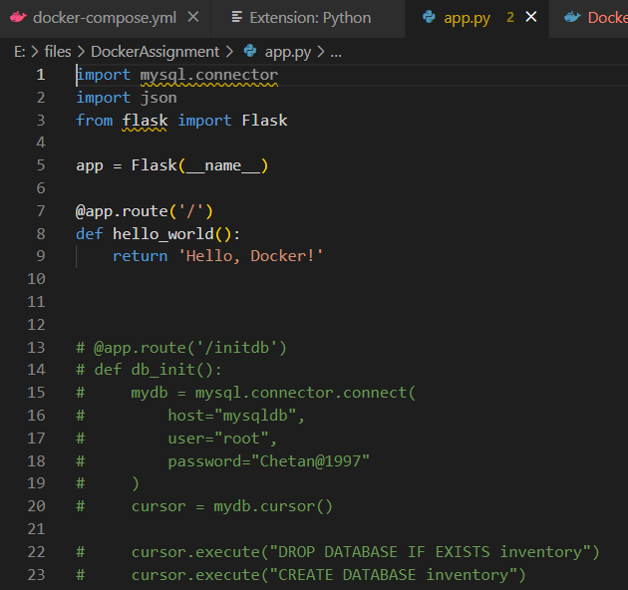

Docker Compose file

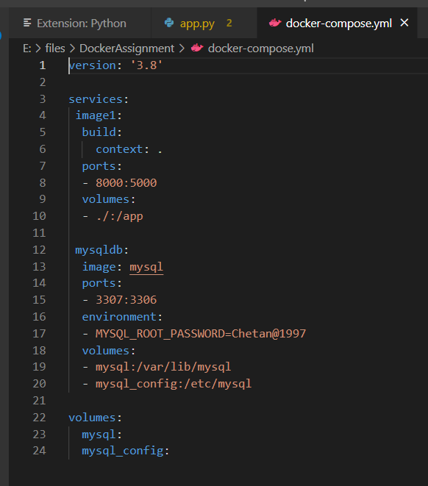

Docker file

Output



